17th Annual Community Food Drive - week ending Sat 7 May 2022
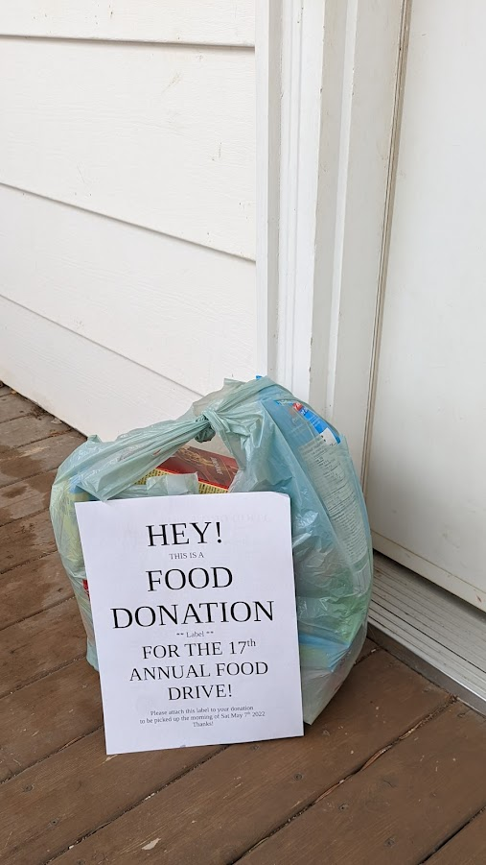 .. this is the idea for pick ups ..
Latest News: see http://www.magrathlions.com/news/category/food%20drive
- lethbridgefoodbank.ca and magrathlions.com
​FOOD DRIVE 2022 - Volunteer Notes –
Benefiting the Lethbridge Food Bank and Area Sponsored by:
You! Representatives from the Churches from Magrath and surrounding area and local volunteers as coordinated by members of the Magrath Lions Club.
Thank you for Volunteering! Here are some operational notes:

- The best time to leave between dropping off flyers and the pick-up on Saturday seems to be 2 to 3 days (May 2-6). One week is the maximum time that should be left between drop off and pick-up.
- It is important to remember to return to every house twice where flyers were delivered to check if food was left for collections. Donors are often very frustrated if they try to donate food and it is not collected when stated.
- First collection is at 9:00 am on Saturday not earlier.
Second collection is at 10:00 am on Saturday not earlier (aka ‘going the 2nd mile’).
- Please go up to each door, check on both left and right. If there is a storm door, check in between the doors. Look for boxes or other bags.
- Do not knock on doors .. do not ring the bell.
- Remember, as community food drive workers, we are representing the Food Bank. Please respect the donors property and treat those in the community with respect. Do not walk on the grass or flowerbeds.
- If your group cannot complete the area assigned, please let Lion Roger or Shauna (403) 388-4332 know so that others can be assigned to that area.
- Please don't be late. Start on time. Thank you!
- Bring everything collected to the Magrath Senior Citizen Center rear parking lot. Our loaded Trucks will leave from there for Lethbridge between 11:30 am and noon on Sat 7 May 2022. Thank you again! Magrath Lions Club

Reminder: We load and unload food bank donations at the Magrath Seniors Center rear parking lot Saturday morning. Loading of trailer starts about 9:30am. We will plan to leave for Lethbridge Food Bank after 11:30am and be unloaded in Lethbridge by 1pm or thereabouts.
Flyers have been printed for each area. We have new volunteer organizers each this year so some advance training may be required (see operational notes above).

